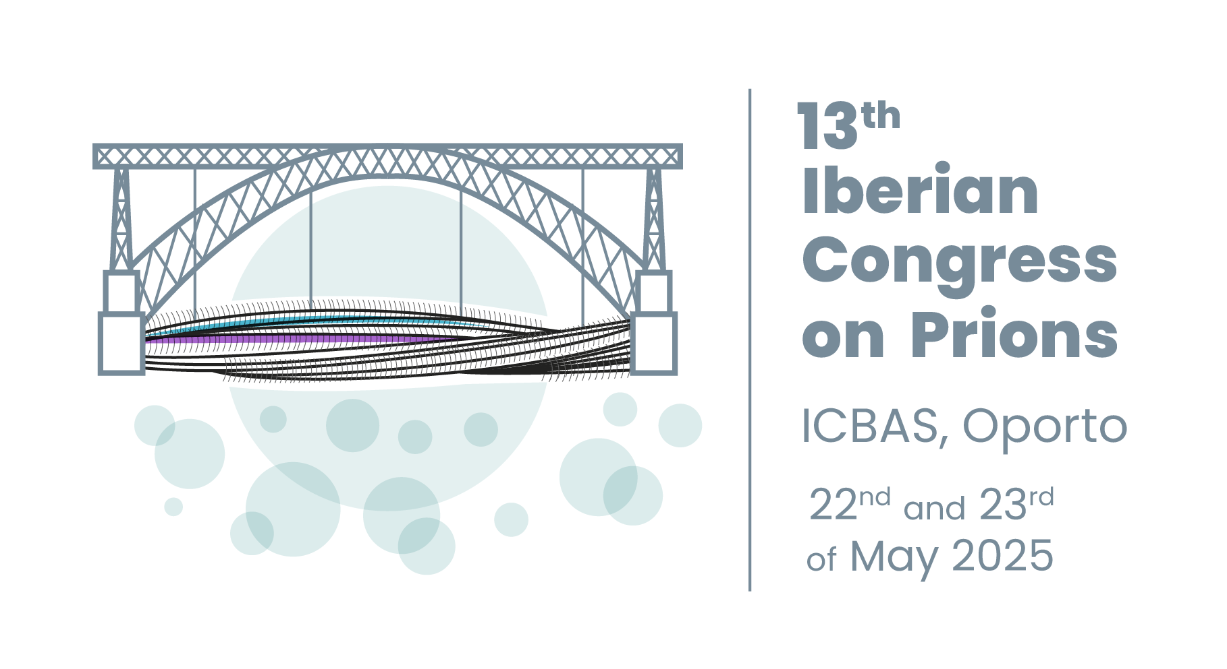

|  |  |  |  |
| --- | --- | --- | --- |
| **APPLICATION FORM 13th Iberian Congress on Prions**  ***Oporto, 22nd-23rd May 2025***  **Fill in the form and submit it online:** | | | |
| Participant: | | | |
| First name | Clique ou toque aqui para introduzir texto. | | |
| Last name | Clique ou toque aqui para introduzir texto. | | |
| Institution/Department | Clique ou toque aqui para introduzir texto. | | |
| Address | Clique ou toque aqui para introduzir texto. | | |
| City/ Zip code | Clique ou toque aqui para introduzir texto. | | |
| Country | Clique ou toque aqui para introduzir texto. | | |
| Telephone number | Clique ou toque aqui para introduzir texto. | | |
| E-mail | Clique ou toque aqui para introduzir texto. | | |
| Attending the congress dinner (60 €)  (Friday 23rd May) | **Yes**  **No** | | |
| Dinner will be served on board a boat trip on the Douro River (maximum 50 people). Dinner includes a choice of "Francesinha", grilled chicken steaks or vegetarian lasagne. Please tick the dinner option on the form | | | |
| Menu option | **Francesinha**  **grilled chicken steaks**  **vegetarian lasagne** | | |
| In order to facilitate the administrative process, please indicate in the boxes below: NIF/VAT, Individual or Collective NIF; name of the person or entity to issue a receipt and the address. | | | |
| NIF/VAT |  | Individual | Collective |
| Full name | Clique ou toque aqui para introduzir texto. | | |
| Address | Clique ou toque aqui para introduzir texto. | | |
| PAYMENT:  By bank transfer to the following account:  IBAN: PT50003300000000038678273  BIC/SWIFT: BCOMPTPL  Note: Please, specify in the details of the bank transfer: “Prion2025 (space) First_Name (space) Last_Name”.  ▪ The registration fee is 130€ and includes documentation, attendance at scientific sessions, coffee breaks and meals. Anyone wishing to attend the conference dinner (Friday 23rd May), must check the appropriate box on the Registration Form and add 60 € to the deposit, making a total of 190 €.  ▪ To formalize registration in the 13th Iberian Congress on Prions is necessary to submit a copy of the Application Form and a receipt of the bank transfer to the Organization by email:  [prions2025@iniav.pt](mailto:prions2025@iniav.pt)  ▪ Registration will not be complete until payment is made, and the receipt is sent by e-mail along with the registration form. | | | |